Apol Medrano
Heritage University 10-30-23
Mathematics and Computer Science Dept. Due: 11-05-23

C++
Homework 7
(pointers, dynamic arrays, class,strings )

1. Prepare a program that return a new dynamic array where all repeated letters are deleted instead of modifying the partially filled array. Don’t forget to free the memory allocated for these returned dynamic arrays when the data is no longer needed. Ch.9,

//HW7 Q1 Apol Medrano
//returning dynamic array with non-repeating letters
#include <iostream>
#include <string>
#include <cctype>
using namespace std;

typedef char* CharArrayPtr;
//defines char pointer as a data type
CharArrayPtr NoConsecutive (string line);
//takes in string deletes repeating character from string
//returns char array filled with edited string to main
void FillArray(CharArrayPtr &a, string line);
//takes in empty dynamic array and string
//returns char array filled with edited string within function
int main()
{
string line;
CharArrayPtr a;
cout << "Enter any line of text you'd like: \n";
getline(cin, line);
a = NoConsecutive(line);
cout << endl << "No repeating letters: " << a;
delete []a;
return 0;
}
CharArrayPtr NoConsecutive(string line)
{
for (int i=0;i<line.length(); i++)
{
for (int j=i+1;j<line.length(); j++)
{
if (tolower(line[i])== tolower(line[j]))
{
line.erase(j,1);
j-=1; //in case multiple
} //repeating letters
} //consecutively appear
}
CharArrayPtr nonRepeatable = new char[line.length()];
FillArray(nonRepeatable, line);
return (nonRepeatable);
}
void FillArray(CharArrayPtr &a, string line)
{
int index;
for (index = 0; index<line.length(); index++)
{
a[index] = line[index];
}
a[index] = '\0';
}

Q1 OUTPUT:
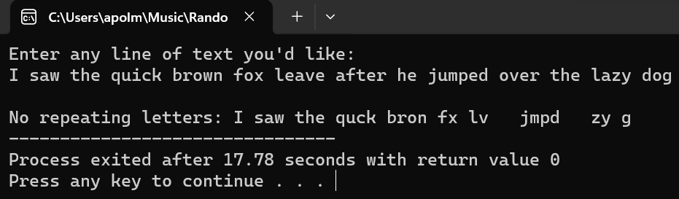

2.Redefine CDAccount from display 10.1 so that it is a class rather than a structure. Use the same member variables as in display 10.1 but make them private. Ch.10

//HW7 Q2 Apol Medrano
//Class for a bank certificate of deposit
#include <iostream>
using namespace std;

class CDAccount
{
public:
CDAccount();
//intializes CDAccount accountVar balance, interestRate
// and term to zero
CDAccount(double theBalance, double theInterestRate, int theTerm);
//intializes CDAccount accountVar balance, interestRate
// and term to values within the parenethesis when created
void Output(ostream& outs);
//displays current balance, interestRate & term of user's CDaccount
void userPrompt(CDAccount& theAccount, int Account_ID);
//Preconditon: User's account is created and intialized
//Postcondition: Either intialized values remain the same or
// user will now go and update it
void getData(CDAccount& theAccount, int Account_ID);
//Precondition: User choose to update his account
//Postcondition: User's inputs are now the balance, interestRate & term
bool check(double theBalance, double theInterestRate, int theTerm);
//Precondition: User inputed the balance, interestRate & term
//Postconditon: User's inputs are legal or illegal
void set(double theBalance, double theInterestRate, int theTerm);
//Precondtion: User's inputed balance, interestrate & term are legal
//Postconditon: User's account will be update will the inputed values
void Maturity(CDAccount theAccount, int Account_ID);
//Precondition: User's account is satisfactory to user and has legal values
//Postcondition: User's account will show the values it will have when matured

private:
double balance;
double interestRate;
int term; //months until maturity
};

int main()
{
CDAccount account1, account2(500.75, 7.5, 6);
int account1_ID = 1, account2_ID = 2;
account1.userPrompt(account1, account1_ID);
account2.userPrompt(account2, account2_ID);
account1.Maturity(account1, account1_ID);
account2.Maturity(account2, account2_ID);
return 0;
}
CDAccount::CDAccount() : balance(0.0), interestRate(0.0), term (0)
{

}
CDAccount::CDAccount(double theBalance, double theInterestRate, int theTerm)
{
balance = theBalance;
interestRate = theInterestRate;
term = theTerm;
}
void CDAccount::userPrompt (CDAccount& theAccount, int Account_ID)
{
char ans;
cout << "Account " << Account_ID << " statement: ";
theAccount.Output(cout);
cout << "Would you like to update it? (Y for Yes, N for N)\n";
cin >> ans;
cout << endl;
if ((ans == 'Y') || (ans == 'y'))
getData(theAccount, Account_ID);
}
void CDAccount::Output(ostream& outs)
{
outs.setf(ios::fixed);
outs.setf(ios::showpoint);
outs.precision(2);
outs << "Account balance $" << balance << endl;
outs << "Interest rate " << interestRate << "%" << endl;
outs << "Months until maturity: " << term << " months\n";
}
void CDAccount::getData(CDAccount& theAccount, int Account_ID)
{
double theBalance, theInterestRate;
int theTerm;
bool evalution;
do
{
cout << "Account " << Account_ID << ":\n"
<< "Enter account balance: $";
cin >> theBalance;
cout << "Enter account interest rate: ";
cin >> theInterestRate;
cout << "Enter the number of months until maturity\n"
<< "(must be 12 or fewer months): ";
cin >> theTerm;
evalution = check(theBalance, theInterestRate, theTerm);
cout << endl;
} while (evalution != true);
theAccount.set(theBalance, theInterestRate, theTerm);
userPrompt(theAccount, Account_ID);
}
bool CDAccount::check(double theBalance, double theInterestRate, int theTerm)
{
if ((theBalance < 0) || (theTerm < 0) || (theTerm > 12))
{
cout << "Invalid input. Please try again!" << endl;
return (false);
}
else
return (true);
}
void CDAccount::set(double theBalance, double theInterestRate, int theTerm)
{
balance = theBalance;
interestRate = theInterestRate;
term = theTerm;
}
void CDAccount::Maturity(CDAccount theAccount, int Account_ID)
{
double rateFraction, interest;
rateFraction = interestRate / 100.0;
interest = balance * rateFraction * (term / 12.0);
balance = balance + interest;

cout.setf(ios::fixed);
cout.setf(ios::showpoint);
cout.precision(2);
cout << "Account " << Account_ID
<< ":\n" << "When your CD matures in "
<< term << " months\n"
<< "with the interest rate of "
<< interestRate << " percent, \n"
<< "it will have a balance of $"
<< balance << endl << endl;
}
Q2 OUTPUT:
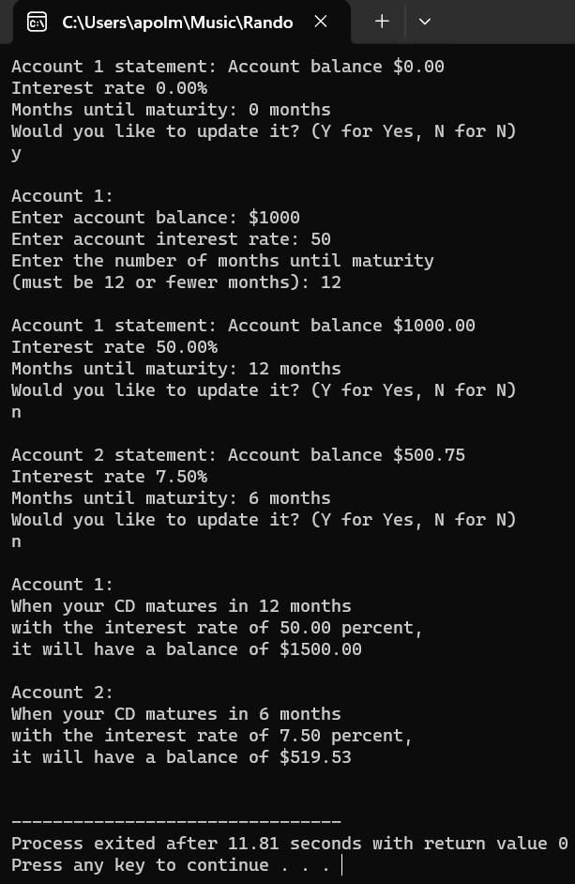

3. Prepare a program that can see if two strings are equal. It is preferred the use of function and pointers. Please use Boolean.

//HW7 Q3 Apol Medrano
//Compares two strings using pointers
#include <iostream>
#include <string>
using namespace std;

bool StringEquality (string* text1, string* text2);
//evalutes two string if they are equal or not
//returns true or false
int main()
{
string* text1 = new string;
string* text2 = new string;

cout << "Enter first line of text:\n";
getline(cin, *text1);
cout << "\nEnter second line of text:\n";
getline(cin, *text2);

if (StringEquality(text1,text2))
cout << "\nThey are the same!\n";
else
cout << "\nThey aren't the same!\n";

delete text1;
delete text2;
return 0;
}
bool StringEquality (string* text1, string* text2)
{
if (*text1 == *text2)
return (true);
else
return (false);
}

OUTPUT DOWN BELOW:

Q3 OUTPUT IF TRUE:
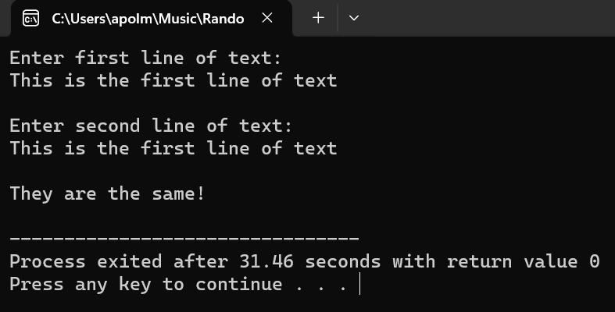

Q3 OUTPUT IF FALSE:
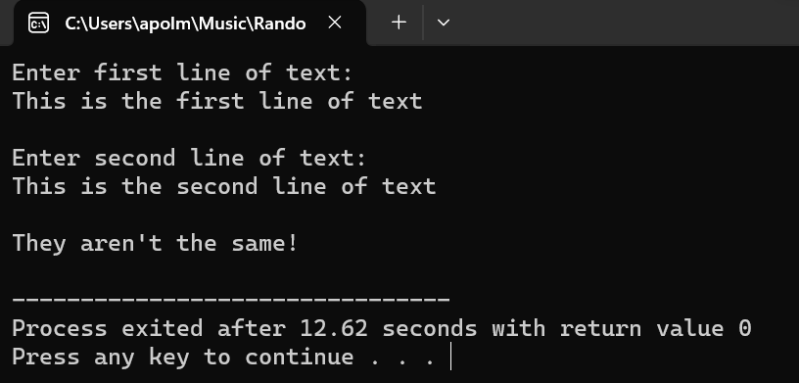

4. Consider 4 computer labs with workstations as below:
Lab Number Computer Stations
1 1: empty 2: empty 3: empty 4: empty 5: empty
2 1: empty 2: empty 3: empty 4: empty 5: empty 6: empty
3 1: empty 2: empty 3 3: empty 4: empty
4 1: 99577 2: empty 3: empty
The user login to labs with the 5digits ID number and get an empty workstation.
Example: if user 49193 logs onto station 2 in lab 3, then your system receives (49193, 2, 3) as input data. Similarly, when a user logs off a station, then your system receives the lab number and
computer station number.
Prepare a program that can track by lab which user is logged onto and which computer.
When a use with ID 99577 is logged into workstation 1 and lab 4 then the system might display :
Lab Number Computer Stations
1 1: empty 2: empty 3: empty 4: empty 5: empty
2 1: empty 2: empty 3: empty 4: empty 5: empty 6: empty
3 1: empty 2: empty 3: empty 4: empty
4 1: 99577 2: empty 3: empty

A menu with operations has to be created:
0;quit
1:login
2:logoff
3:search
Solution

//HW7 Q4 Apol Medrano
//Computer lab
#include <iostream>
#include <string>
#include <cstdlib>
using namespace std;

class Network
{
public:
Network();
//intializes with no users logged in
void startLabs ();
//intializes labs to zero
//boots labs up or kicks all user's off
void menu();
//runs main menu, either exit, login, logoff, or search
private:
int user_ID;
int station;
int labNum;
int lab_one[5];
int lab_two[6];
int lab_three[4];
int lab_four[3];
bool check(int theUser_ID, int theStation, int theLabNum);
//Used for login: checks UserID, station & labNum are not
//illegal values and if station is open to log into
bool check (int theStation, int theLabNum);
//Used for logout: checks station & labNum are not illegal
//values and there is a user to logout at specific station
void getLab(int theUser_ID, int theStation, int theLabNum);
//takes in User_ID, the station and theLabNum and updates
//the specific workstation inputed with User_ID
void login();
//prompts input for user_id and the specific lab
// & workstaton they will be logging on to
void logoff();
//prompts input for specific lab & workstation
// that will log a user off
void search();
//shows all the labs and their workstations
//displays which ones are open or are occupied by user
};
int main()
{
Network Overseer;
Overseer.startLabs();
Overseer.menu();
return 0;
}
void Network::startLabs ()
{
int index;
for (index = 0; index < 5; index++)
lab_one[index] = 0;
for (index = 0; index < 6; index++)
lab_two[index] = 0;
for (index = 0; index < 4; index++)
lab_three[index] = 0;
for (index = 0; index < 3; index++)
lab_four[index] =0;
return;
}
Network::Network() : user_ID(0), station(0), labNum(0)
{

}
void Network::getLab(int theUser_ID, int theStation, int theLabNum)
{
switch(theLabNum)
{
case 1:
lab_one[theStation-1] = theUser_ID;
break;
case 2:
lab_two[theStation-1] = theUser_ID;
break;
case 3:
lab_three[theStation-1] = theUser_ID;
break;
case 4:
lab_four[theStation-1] = theUser_ID;
break;
default:
break;
}
}
void Network::menu()
{
int selection;
do
{
cout << "MAIN MENU\n";
cout << "0:quit\n1:login\n2.logoff\n3.search\n";
cin >> selection;
switch(selection)
{
case 0:
return;
break;
case 1:
login();
break;
case 2:
logoff();
break;
case 3:
search();
break;
default:
cout << "\nInvalid entry. Re-enter choice.\n\n";
break;
}
} while ((selection < 0) || (selection > 3));
}
bool Network::check(int theUser_ID, int theStation, int theLabNum)
{
if ((theUser_ID < 10000) || (theUser_ID > 99999))
{
cout << "Invalid User ID. Try again\n";
return (false);
}
switch(theLabNum)
{
case 1:
if ((theStation<1)||(theStation>5))
{
cout << "Invalid station number. Try again\n";
return (false);
}
if (lab_one[theStation-1] != 0)
{
cout << station << " at " << theLabNum << " taken. Try again.\n";
return (false);
}
break;
case 2:
if ((theStation<1)||(theStation>6))
{
cout << "Invalid station number. Try again.\n";
return (false);
}
if (lab_two[theStation-1] != 0)
{
cout << station << " at " << theLabNum << " taken. Try again.\n";
return (false);
}
break;
case 3:
if ((theStation<1)||(theStation>4))
{
cout << "\nInvalid station number. Try again.\n";
return (false);
}
if (lab_three[theStation-1] != 0)
{
cout << station << " at " << theLabNum << " taken. Try again.\n";
return (false);
}
break;
case 4:
if ((theStation<1)||(theStation>3))
{
cout << "Invalid station number.\n";
return (false);
}
if (lab_four[theStation-1] != 0)
{
cout << station << " at " << theLabNum << " taken. Try again.\n";
return (false);
}
break;
default:
cout << "Invalid lab number. Try again.\n";
return (false);
break;
}
return (true);
}
bool Network::check (int theStation, int theLabNum)
{
switch(theLabNum)
{
case 1:
if ((theStation<1)||(theStation>5))
{
cout << "Invalid station number. Try again\n";
return (false);
}
if (lab_one[theStation-1] != 0)
return (true);
else
{
cout << "No user at lab " << theLabNum
<< " at workstation " << theStation << ".";
return (false);
}
break;
case 2:
if ((theStation<1)||(theStation>6))
{
cout << "Invalid station number. Try again.\n";
return (false);
}
if (lab_two[theStation-1] != 0)
return (true);
else
{
cout << "No user at lab " << theLabNum
<< " at workstation " << theStation << ".";
return (false);
}
break;
case 3:
if ((theStation<1)||(theStation>4))
{
cout << "\nInvalid station number. Try again.\n";
return (false);
}
if (lab_three[theStation-1] != 0)
return (true);
else
{
cout << "No user at lab " << theLabNum
<< " at workstation " << theStation << ".";
return (false);
}
break;
case 4:
if ((theStation<1)||(theStation>3))
{
cout << "Invalid station number.\n";
return (false);
}
if (lab_four[theStation-1] != 0)
return (true);
else
{
cout << "No user at lab " << theLabNum
<< " at workstation " << theStation << ".";
return (false);
}
break;
default:
cout << "Invalid lab number. Try again.\n";
return (false);
break;
}
return (true);
}
void Network::login()
{
bool evalution;
do
{
cout << "\nEnter 5 digit ID number:\n";
cin >> user_ID;
cout << "Enter lab number: (1 through 4)\n";
cin >> labNum;
cout << "Enter workstation number:\n";
cin >> station;
evalution = check(user_ID,station,labNum);
} while (evalution != true);
getLab(user_ID,station,labNum);
cout << "User " << user_ID
<< " logged on workstation number "
<< station << " in lab number " << labNum << ".\n"
<< "Returning to main menu." << endl << endl;
}
void Network::logoff()
{
cout << "Enter lab number: (1 through 4)\n";
cin >> labNum;
cout << "Enter workstation number:\n";
cin >> station;
user_ID = 0;
if (check(station, labNum))
{
getLab(user_ID,station,labNum);
cout << endl << "User has been"
<< " logged off from workstation number "
<< station << " in lab number " << labNum << ".\n";
}
cout << "Returning to main menu." << endl << endl;
}
void Network::search()
{
int index;
cout << "\nLab 1 ";
for (index = 0; index < 5; index++)
{
cout << index+1 << ":";
if (lab_one[index] == 0)
cout << "empty" << " ";
else
cout << lab_one[index] << " ";
}
cout << "\nLab 2 ";
for (index = 0; index < 6; index++)
{
cout << index+1 << ":";
if (lab_two[index] == 0)
cout << "empty" << " ";
else
cout << lab_two[index] << " ";
}
cout << "\nLab 3 ";
for (index = 0; index < 4; index++)
{
cout << index+1 << ":";
if (lab_three[index] == 0)
cout << "empty" << " ";
else
cout << lab_three[index] << " ";
}
cout << "\nLab 4 ";
for (index = 0; index < 3; index++)
{
cout << index+1 << ":";
if (lab_four[index] == 0)
cout << "empty" << " ";
else
cout << lab_four[index] << " ";
}
cout << endl << endl;
return;
}

Q4 OUTPUT DOWN BELOW:

Q4 OUTPUT:
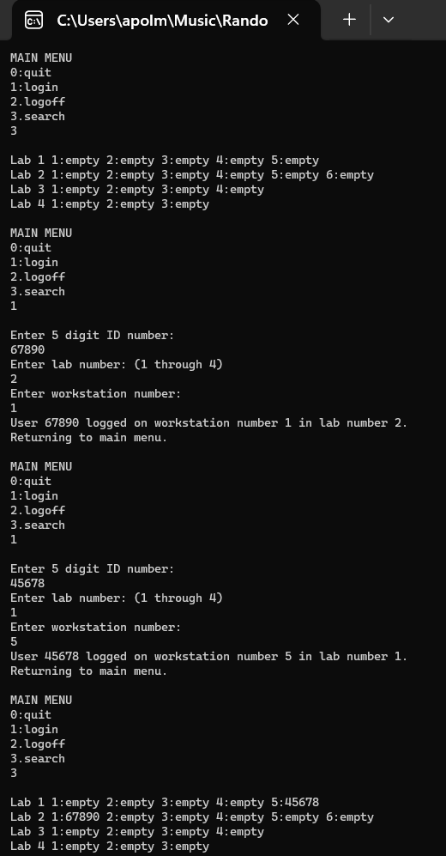

OUTPUT CONTINUED:
